## **Use case**

| **Platform development: Another-1 ISO Launchpad** | |
| --- | --- |
| Client Name | ANOTHER 1 Pte Ltd |
| Project Name | Another-1 ISO Launchpad |
| Document Status | Version 0.1 |
| Target Release | September, 2022 |
| Project Manager | Charlotte Volet |
| Blockchain Lead | Alexander Filatov |
| Tech Leader | Conor Clancy |
| QA | TBD |
| EPICS/Features | The scope of work will be split within three main verticals, the AN1 token – a ERC20 token to be issued in the Polygon blockchain –, the ISO Launchpad – that will provide the digital infrastructure for the launch of new NFT collections –, and a rewards engine – that will incentivize activities and participation in the platform. |

**Document Changelog**

| Changes | Edited By/On | Date | V |
| --- | --- | --- | --- |
|  |  |  |  |
|  |  |  |  |
| Van Tran Thao | Initial document | 12/12/2022 |  |

## Table of contents

**Table of contents** **2**

**PBI 1. Become a creator** **3**

1.1. Description 3

1.2. Flow diagram 3

1.3. Use case 3

**PBI 2. The two stages sales** **3**

2.1. Description 3

2.2. Flow diagram 3

2.3. Use case 3

**PBI 3. The migration of the NTR1 meta collection NFTs to AN1 platform** **3**

3.1. Description 3

3.2. Flow diagram 3

3.3. Use case 3

**PBI 4. Fractal KYC** **4**

4.1. Description 4

4.2. Flow diagram 4

4.3. Use case 4

## Figma’s flow [here](https://www.figma.com/file/bk3Ere3JQ2GOZR7089jrKs/AN1_Flows?node-id=0%3A1&t=nwUxkp0KbuHUdyPW-1).

## PBI 1. Become a creator

### 1.1. Description

When a user arrives on the AN1 platform, the user can see the Become a creator button at the top of the navigation bar. If a user wants to have all permissions of the creator in the AN1 platform, just click on the Become a creator button, take some steps then follow the guidance.

Right after the user clicks on the Become a creator button, the user will be redirected to the Form. Here, the user needs to fill out all the fields, especially the required fields. When all inputted information is ready to send to the AN1 group team to review, click on the Submit button to submit the information. Next, the user needs to confirm certain information. If the user does not accept the confirmation, the system will re-back the user to the Fill in Form steps in order to fill in again certain information before submitting the form. On the contrary, the form is submitted and is sent to the AN1 group team to review. AN1 platform supports users to understand the flow of working here by sending the confirmation email and process explanation. Simultaneously, the application sends an email to the AN1 group team to review the submitted form. User can be free for about 2 weeks while waiting for the review result. If the submitted form is not rejected, the application will send an ejection email to the user to notify. And if the submitted form is approved, the application will send an email approval to the user, and instructions to create wallet and account and email to AN1 the attached guidelines for the user in order to do the steps by themselves.

### 1.2. Flow diagram

### 

### 1.3. User Story, Use case

User Story

| Feature | Story | Tasks |
| --- | --- | --- |
| Become a creator | As a potential creator, I would like to be able to provide my details and portfolio for review so that I can have all the permission of the creator in AN1 platform. |  |

Use Cases

| Name | Become a creator |
| --- | --- |
| Actor | Default user |
| Description | User clicks on the Become a creator button as arriving the AN1 platform |
| PreCondition | User arrives to the AN1 platform |
| Normal Path | S05. User clicks on the Become a creator button  S10. System shows the Form  S15. User fills in all required fields in the Form  S20. User clicks on the Submit button  S25. System displays the Confirmation pop-up  S30. User reviews and clicks on the confirm button  S35. System displays the Application sent pop-up  S40. The form is submitted.  S45. The application sends user email of confirmation and the process explanation  S50. The application sends AN1 group team the email to review the submitted form  S55. The application sends user email of approval, and the instruction of creating wallet, account, and email  S60. Ends |
| Alternative Path(s) | A01. @S35. User does not confirm  A01. S05. System turns user back to Fill in form steps  A02. @S55. AN1 group team rejects the submitted form  A02. S05. The application sends user email of rejection |
| Post Conditions | User is approved the submitted form and takes the next steps of becoming creator |
| Assumptions | None |

### 

## 

## PBI 2. Redemption Process (The two stages sales)

### 2.1. Description

The sales for now is divided into two stages, which the first step is the minting of the digital asset with an initial payment, and the second step is forging/redeem the physical item with a second round of payment.

Some collections may only have the initial sale (during minting) and free redemption/forging. And most of collections will go through 2 stages of sale.

Users mint their NFT. They pay all the payment of minting process. And then, users take some process of redeeming. This flow below will describe detaily about the process of redeeming.

### 2.2. Flow diagram

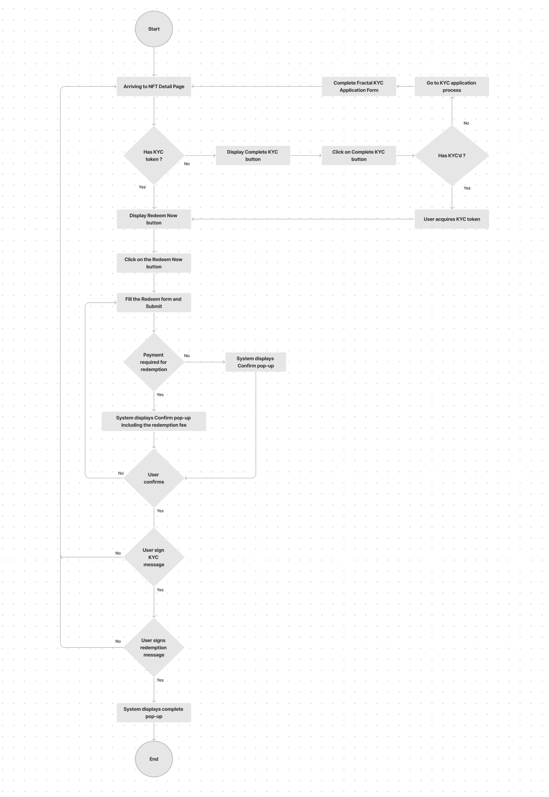

### 2.3. User Story, Use case

User Story

| Feature | Story | Tasks |
| --- | --- | --- |
| Redemption | As a user, I would like to fill the form of redemption and take some required process of redemption, so that I can redeem my interested physical item (NFT). |  |

Use Cases

| Name | Redemption Process (The two stages of sale) |
| --- | --- |
| Actor | User |
| Description | Users go to the NFT Detail Page to jump into Redemption Process |
| PreCondition | Users **completed** the use case of Get Fractal KYC Token (NFT Detail Page) |
| Normal Path | S05. Users click on the Redeem Now button  S10. System displays the Redeem form  S15. Users fill all the required fields of the form and submit  S20. System displays Confirm pop-up including the redemption fee if it has the payment required for redemption  S25. User confirms the information  S30. User signs the KYC message  S35. User signs the redemption message to complete  S40. System displays the Complete pop-up  S45. End |
| Alternative Path(s) | A01. @S20. If it does not have the payment required for redemption  A01. S05. System display the confirmation pop-up  A01. S10. Go to the S25. (Normal path)  A02. @S25. Users do not confirm the information  A02. S05. Redirect users back to the Fill the form (S15)  A03. @S30. Users do not sign the KYC message  A03. S05. Redirect users back to the NFT Detail Page  A04. @S35. User does not sign the message  A04. S05. Redirect users back to the NFT Detail Page |
| Post Conditions | User completed the redemption the physical item |
| Assumptions | None |

### 

## 

## PBI 3. Convert ERC 1155 to ERC 721 (The migration of the NTR1 meta collection NFTs to AN1 platform)

### 3.1. Description

In AN1 platform, all of the NFTs is made from ERC 721. NTR1 meta collection which is a collection outside the AN1 platform. NFT in NTR1 meta collection is created before the releasing of AN1 platform and the type of NFT is from ERC 1155.

The NTR1 meta collection is brought to the AN1 platform and as the result, it needs to converting.

When users come to AN1 platform, they go to the converting page, select the NFT collection, input the amount. AN1 system will create a new one of NFT which is the same with the NTR1’s NFT, system destroy the ERC 1155 and gives to users the ERC 721 one.

For using that solution, user could keep and interact with the NTR1 meta collection right in the AN1 platform.

### 3.2. Flow diagram

### 

### 3.3. User Story, Use case

User Story

| Feature | Story | Tasks |
| --- | --- | --- |
| Convert ERC 1155 to ERC 721 | As a user, I would like to take some steps of converting, so that I could convert some of my NFT from ERC 1155 to ERC 721 |  |

Use Cases

| Name | Convert ERC 1155 to ERC 721 |
| --- | --- |
| Actor | User |
| Description | User arrives to platform and choose Converting function |
| PreCondition | Users are now viewing the screen of Converting |
| Normal Path | S05. User selects the type of NFT which he wants to convert from ERC 1155 to ERC 721  S10. The NFT is selected by ticking the checkbox  S15. User inputs the convert AMT  S20. System calculates and displays the total of converting tokens  S25. User clicks on Convert Now button  S30. System displays the Confirm pop-up for user to confirm the information of converting  S35. User confirms the information  S40. Display the Sign the message  S45. User sign the message  S50. System displays the Convert successfully pop-up  S55. Ends |
| Alternative Path(s) | A01. @S35. User does not confirm the information (click on teh Back button)  A01. S05. Redirect user back to S05.  A02. @S45. User does not sign the message  A02. S05. Redirect user back to S05. |
| Post Conditions | NFT which user selects is converted successfully from ERC 1155 to ERC 721 |
| Assumptions | None |

### 

## PBI 4. Get Fractal KYC Token

### 4.1. Description

KYC is known as Know Your Customer. KYC is a necessary verification identity process used in finance, bank, or money transactions. KYC ensures the registered customers are real customers. For the customer is not provide minimum requirements, system will reject take transaction or temporarily suspend co-operation. Requesting customers to provide complete and detailed information makes sure that they are not related to the corruption, bribery or money laundering.

In AN1 platform, KYC enables users to request redemption. All other features besides redemption are availableto both KYC and non-KYC users. KYC will be applied before the redemption process , and if users are not already on Fractal, it will redirect them to Fractal.

ANI platform requires KYC for the redemption of the physical product.

Before displaying the shipping address form which is usually displayed after clicking the Redeem Now button on the NFT Detail Page, ANI platform check if users have a valid KYC token from Fractal. If not, ANI platform redirects them to Fractal KYC flow. If they are not KYC’d with Fractal already, they will have to go through the KYC application process.

It takes “anywhere from a few minutes to a couple of hours” for a KYC application to approved.

If users are KYC'd with Fractal already, they will be able to acquire a KYC token.

Once users acquire a KYC token, ANI platform displays the shipping address form as it is now.

Furthermore, users could go to their own profile and take process of KYC’d.

If users have not KYC token, on the Profile, it will display a GET KYC token button. The process here is the same with the process in the NFT Detail Page. If user are not KYC’d with Fractal, system will redirects users to the KYC application process, and of course, it will take approximately a few minutes or 1-2 hours to be approved the KC’d.

If users are KYC’d with Fractal already, they could acquire the KYC token. At the same time, users are redirected back to their Profile without the Get KYC token button.

### 4.2. Flow diagram

### 

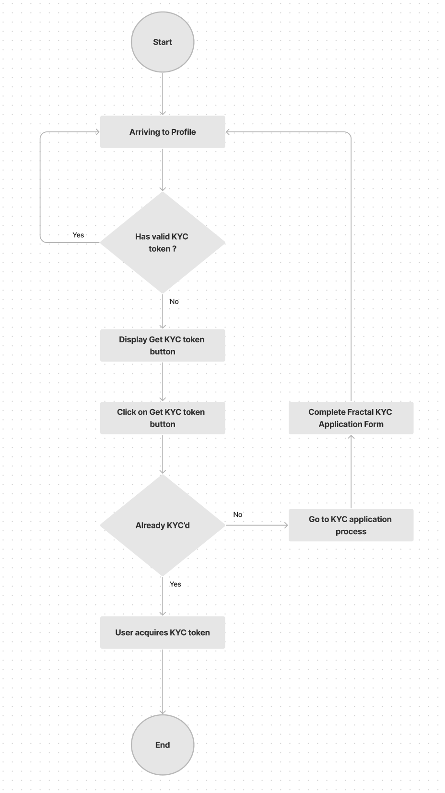

### 4.3. User Story, Use case

User Story

| Feature | Story | Tasks |
| --- | --- | --- |
| Get the KYC token | As a user, I would like to take process of KYC’d and able to get KYC token, so that I can redeem NFT |  |

Use Cases (NFT Detail Page)

| Name | Get KYC token (NFT Detail Page) |
| --- | --- |
| Actor | User |
| Description | User goes to NFT Detail Page |
| PreCondition | User arrives to NFT Detail Page |
| Normal Path | S05. System checks if user has the valid KYC token  S10. Display the Complete KYC button (Case: User does not have the KYC token)  S15. User clicks on the Complete KYC button  S20. System checks if user has the KYC’d  S25. User acquires the KYC token  S30. Display the Redeem Now button  S35. End |
| Alternative Path(s) | A01. @S010. User has the KYC token  S05. Display the Redeem Now button  S10. End  A02. @S25. User does not have the KYC’d  S05. System redirects user to KYC application process  S10. User completes the Fractal KYC application form (outside of AN1 platform)  S15. System re-backs to check if user has the valid KYC token.  (Continue from the S05) |
| Post Conditions | User acquires the KYC token |
| Assumptions | None |

Use Cases (Profile Page)

| Name | Get KYC token (Profile Page) |
| --- | --- |
| Actor | User |
| Description | User goes to Profile Page |
| PreCondition | User arrives to Profile Page |
| Normal Path | S05. System checks if user has the valid KYC token  S10. Display the Get KYC token button (Case: User does not have the KYC token)  S15. User clicks on the Get KYC token button  S20. System checks if user has already the KYC’d  S25. User acquires the KYC token  S30. Display the Profile Page without the Get KYC token button  S35. End |
| Alternative Path(s) | A01. @S010. User has the KYC token  S05. Just display the Profile Page without the Get KYC token button  S10. End  A02. @S25. User does not have the KYC’d  S05. System redirects user to KYC application process  S10. User completes the Fractal KYC application form (outside of AN1 platform)  S15. System re-backs to check if user has the valid KYC token.  (Continue from the S05) |
| Post Conditions | User acquires the KYC token |
| Assumptions | None |

### 